Hardhat setup for software security project
- Setup Hardhat Environment: npx hardhat –init
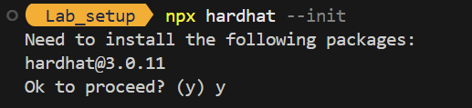
Select “Hardhat 3 Beta”, then select the directory root, then “A Typescript Hardhat project using Mocha and Ethers.js” (maybe the first option is also fine). Then install all the dependencies.
You should have installed all the directories and files for the Hardhat environment.
- Install the ethers.js dependencies from terminal:
npm install --save-dev @nomicfoundation/hardhat-ethers ethers

This module is useful for interacting with the blockchain (ethers.js documentation).
- Edit the hardhat.config.ts file, adding these parts (underlined in red):

import hardhatEthersPlugin from "@nomicfoundation/hardhat-ethers";

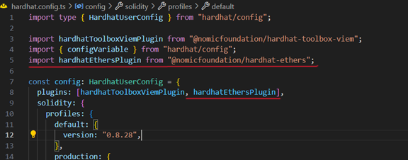
- Create a solidity contract in the contracts folder in the explorer pane:
// SPDX-License-Identifier: MIT
pragma solidity ^0.8.0;

contract HelloEthereum {
string public message; // message is a public state variable storing a string

// Constructor that initializes the contract with a message
constructor(string memory initialMessage) { //The contract’s constructor initializes a message with a value when the contract is deployed.

message = initialMessage;
}

// Function to update the message
function updateMessage(string memory newMessage) public { // updateMessage is a function allowing anyone to change the stored message.
message = newMessage;
}
}
- Open a new terminal window to create the local Ethereum blockchain and run: npx hardhat node
Do not close it or the blockchain shuts down.
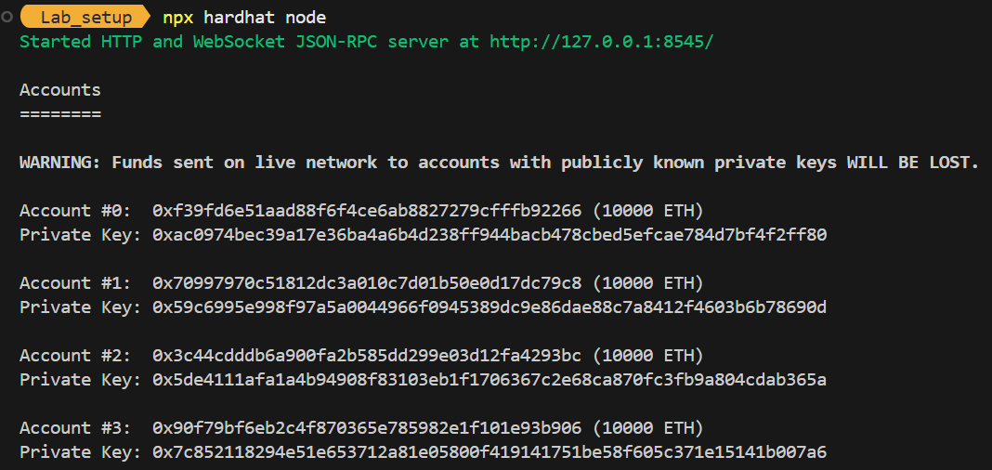

- Write a script in ignition\modules\ helloethereum.ts for the contract deployment with the same name, but the extension should be .ts:

import { buildModule } from "@nomicfoundation/hardhat-ignition/modules";

export default buildModule("HelloEthereumModule", (m) => {
const prova = m.contract("HelloEthereum", [“Test Message”]);
// The first parameter is the contract’s name
//The second is the constructor parameters
return { prova };
});

NOTE: If the deployment has been already done, delete the deployments folder inside the ignition folder in the explorer pane.

- Note that the local blockchain is executed in the node next to the terminal. You’re not allowed to write anything or the blockchain will shutdown.
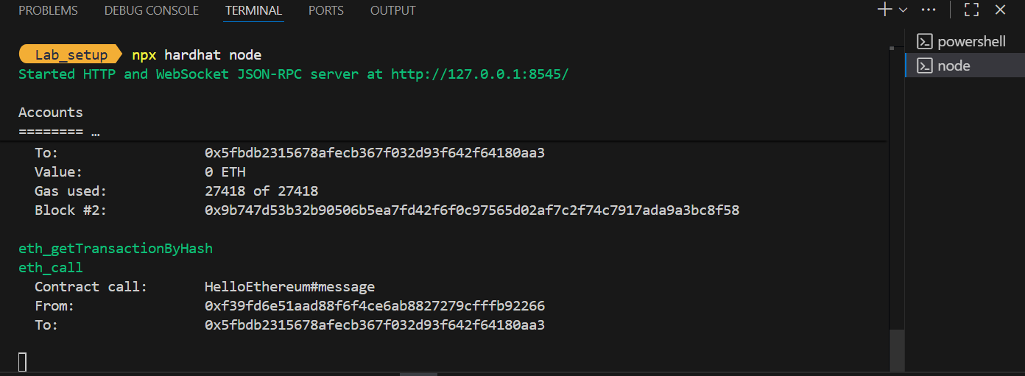

- Exec this command in the terminal to deploy the contract and copy its address in the output:
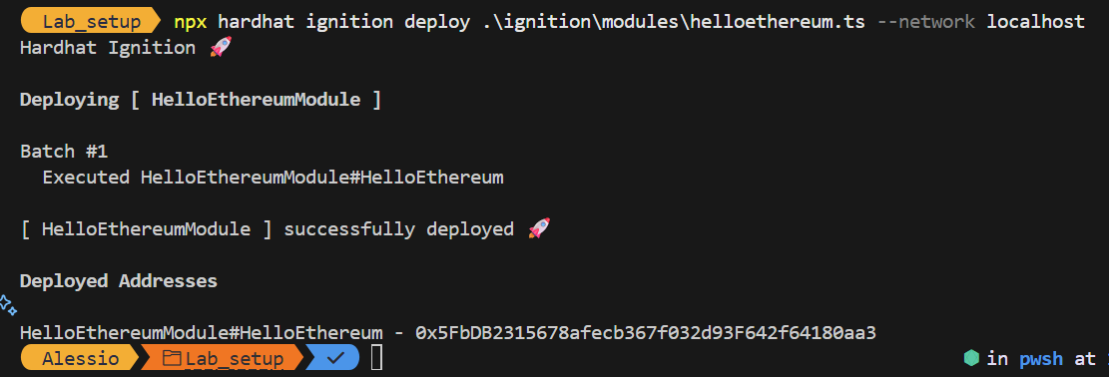
npx hardhat ignition deploy .\ignition\modules\helloethereum.ts --network localhost

- Write a script in scripts/helloethereum_interact.ts to interact with the contract (through the contract address):

import { network } from "hardhat";
const { ethers } = await network.connect();

async function main() {
// 1. Calling contract’s factory (creates a contract instance)
const contractAddress = "<contract address from the previous step>";
const contractDeployed = await ethers.getContractAt("HelloEthereum", contractAddress);

const initialMessage = await contractDeployed.message(); // message() is a getter function that is created automatically by Ethers because we have a public variable named “message”
console.log("Messaggio iniziale:", initialMessage);

// 2. updateMessage function
await contractDeployed.updateMessage("test2");
const updatedMessage = await contractDeployed.message();
console.log("Messaggio aggiornato:", updatedMessage);
}

main().catch((err) => {
console.error(err);
process.exit(1);
});

- Exec this command to interact with the contract and exec the script from the terminal:
npx hardhat run .\scripts\helloethereum_interact.ts --network localhost

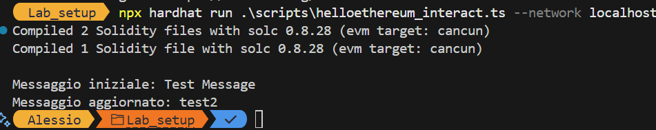
As we can see, the initial message is the one we wrote in the contract’s buildModule, then we updated it thanks to the updateMessage function. We can see the transactions have been registered in our local blockchain (see the terminal in which the hardhat node is running).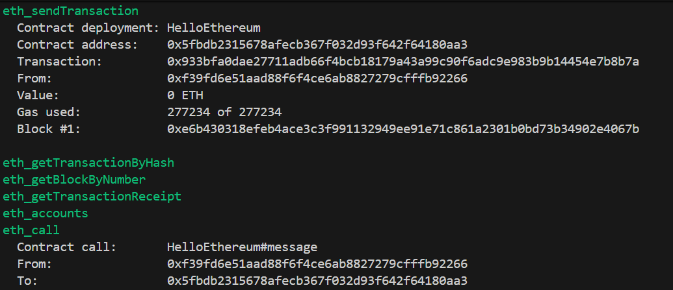
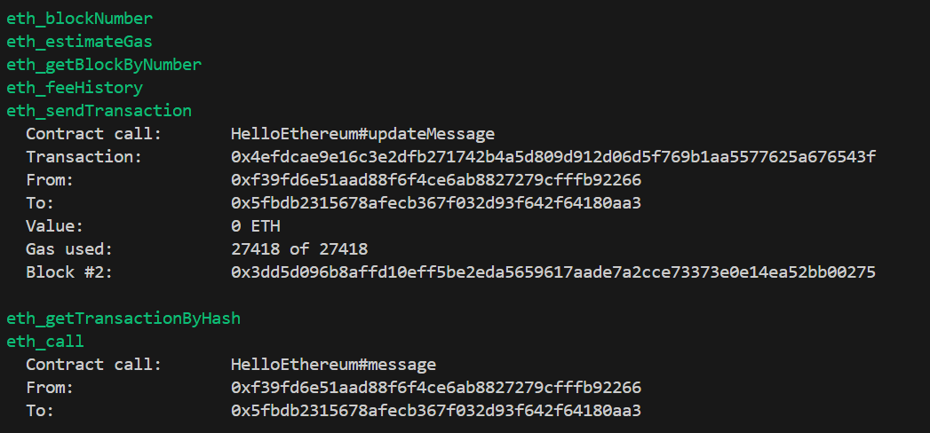
- Install OpenZeppelin: npm install @openzeppelin/contracts
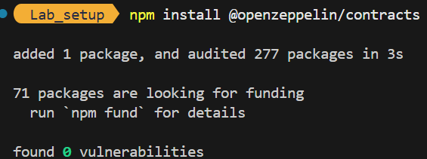
Once installed, you can use OpenZeppelin’s contracts by importing them (example with ERC721 standard):
import {ERC721} from "@openzeppelin/contracts/token/ERC721/ERC721.sol";
Now you are ready to add your contracts!

